ARCHITHA OJHA
2303A52170 – 41
Code Refactoring – Improving Legacy Code with AI Suggestions

Task 1: Refactoring Data Transformation Logic
Scenario
You are maintaining a data preprocessing script where numerical
transformations are written using verbose loops.
Task Description
• Review the legacy code that computes transformed values using
an explicit loop.
• Use an AI tool to suggest a more Pythonic refactoring approach.
• Refactor the code using list comprehensions or helper functions
while preserving the output.
Legacy Code
values = [2, 4, 6, 8, 10]
doubled = []
for v in values:
doubled.append(v * 2)
print(doubled)
Expected Output
[4, 8, 12, 16, 20]

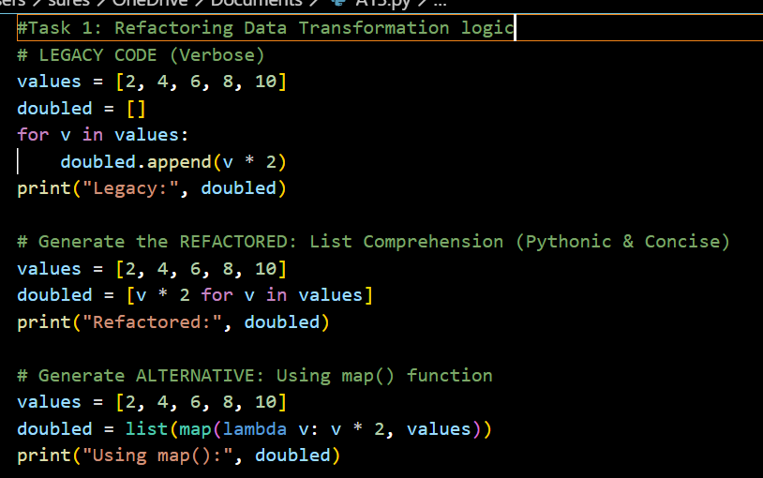
OUTPUT:
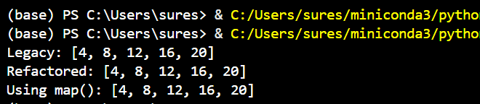

JUSTIFICATION:
The refactor replaces a multi-line loop with a list comprehension, which is the standard Pythonic way to transform collections. It is not only more concise but also faster because it runs at C-speed internally, avoiding the repeated overhead of the .append() method call.

Task 2: Improving Text Processing Code Readability
Scenario
You are working on a log message generator that builds messages word
by word.
Task Description
• Analyze the legacy code that constructs a sentence using repeated
string concatenation.
• Ask AI to suggest a more efficient and readable approach.
• Refactor the code accordingly while keeping the final output
unchanged.
Legacy Code
words = ["Refactoring", "with", "AI", "improves",
"quality"]
message = ""
for w in words:
message += w + " "
print(message.strip())
Expected Output
Refactoring with AI improves quality
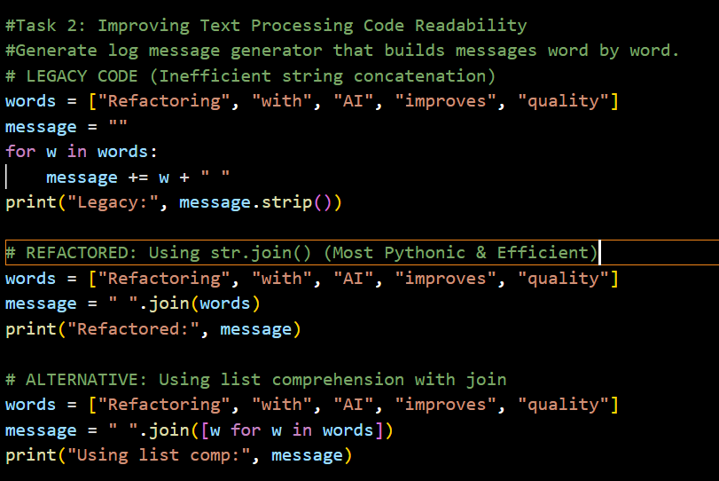
OUTPUT:
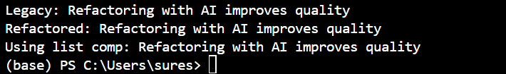
JUSTIFICATION:
Using .join() is a critical optimization for performance. Because Python strings are immutable, using += inside a loop creates a completely new string object in memory at every iteration; .join() avoids this by calculating the total memory needed once and building the final string in a single pass.

Task 3: Safer Access to Configuration Data
Scenario
You are maintaining a configuration loader where dictionary keys may
or may not exist depending on deployment settings.
Task Description
• Review the legacy code that manually checks for dictionary keys.
• Use AI suggestions to refactor the code using safer dictionary
access methods.
• Ensure the behavior remains the same for missing keys.
Legacy Code
config = {"host": "localhost", "port": 8080}
if "timeout" in config:
print(config["timeout"])
else:
print("Default timeout used")
Expected Output
Default timeout used
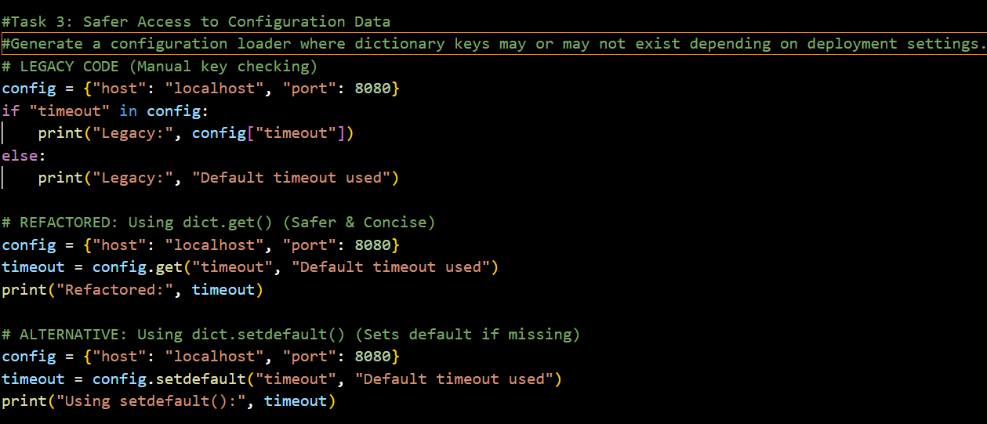
OUTPUT:
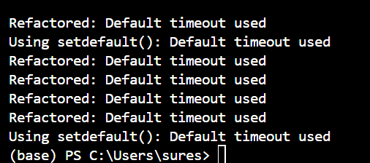
JUSTIFICATION:
The .get() method is a safer approach to dictionary access because it combines the "check" and "retrieval" into one atomic operation. This eliminates the risk of a KeyError and makes the code more readable by removing unnecessary conditional blocks for simple default values.

Task 4: Refactoring Conditional Logic for Scalability
Scenario
You are enhancing a utility module that performs different operations
based on user input.
Task Description
• Examine the multiple if–elif conditions used to determine
operations.
• Ask AI to suggest a cleaner, scalable alternative.
• Refactor the logic using mapping techniques while preserving
functionality.
Legacy Code
action = "divide"
x, y = 10, 2
if action == "add":
result = x + y
elif action == "subtract":
result = x - y
elif action == "multiply":
result = x * y
elif action == "divide":
result = x / y
else:
result = None
print(result)
Expected Output
5.0
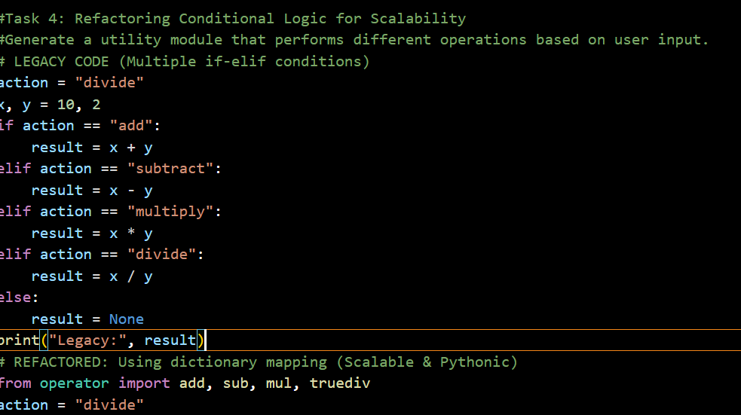
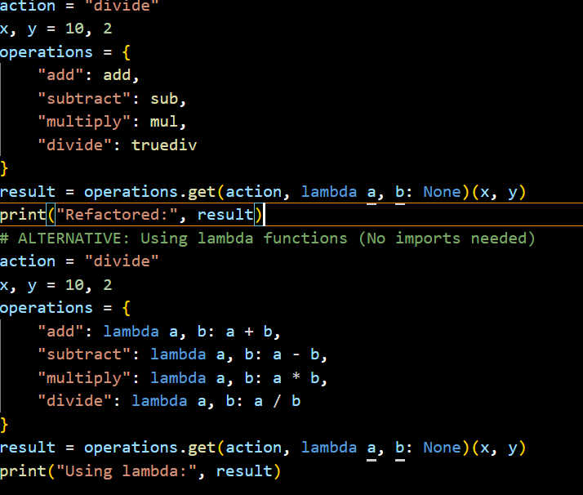

OUTPUT:
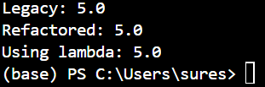
JUSTIFICATION:
Replacing if-elif chains with a Dictionary Dispatch Table makes the code O(1) (constant time) for lookups and highly scalable. It follows the "Open-Closed Principle," allowing you to add new operations by simply updating the dictionary rather than modifying the core logic of the function.

Task 5: Simplifying Search Logic in Collections
Scenario
You are reviewing legacy inventory-check code that uses manual loops
to find elements.
Task Description
• Identify the explicit loop used for searching an item.
• Use AI assistance to refactor the logic into a more concise and
readable form.
• Maintain the same output behavior.
Legacy Code
inventory = ["pen", "notebook", "eraser", "marker"]
found = False
for item in inventory:
if item == "eraser":
found = True
break
print("Item Available" if found else "Item Not Available")
Expected Output
Item Available
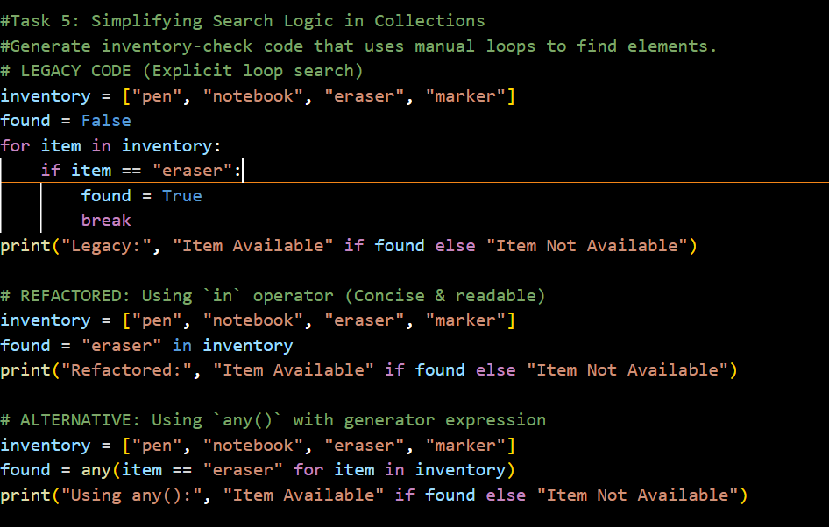
OUTPUT:
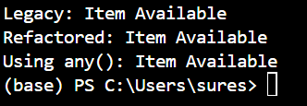

JUSTIFICATION:
The in operator is the most expressive and readable way to check for membership in Python. Under the hood, it is highly optimized; for lists, it performs a linear search in a tight C-loop, and if you ever swap the inventory to a set, the same code would instantly become O(1) without needing to change your logic.

